|  |  |
| --- | --- |
| **Ex. No. 9** | **Arrays and Routing using Angular JS** |
| **Date of Exercise** | 11.10.2023 |

**Aim**

To Develop a web application using Angular JS framework by arrays and routing using html.

**Description**

* The ng-repeat directive repeats a set of HTML, a given number of times. The set of HTML will be repeated once per item in a collection. The collection must be an array or an object.
* If you have an collection of objects, the ng-repeat directive is perfect for making a HTML table, displaying one table row for each object, and one table data for each object property.
* The ng-repeat directive also exposes some variables within the context of the HTML template that gets repeated, which allows us to gain some insight into the current element.
* $index -> gives us the index or position of the item in the array.
* track by $index can be used to retrieve array elements with $index when array contains duplicates items.
* ngView directive is used to display the HTML templates or views in the specified routes. Every time the current route changes, the included view changes with it according to the configuration of the $route service.
* The **ngRoute** module helps in accessing different pages of an application without reloading the entire application.
* AngularJS also provides the ability to pass parameters in routes, which means, it allows us to dynamically generate routes and handle different data based on the parameters.
* $routeProvider is used to configure the routes. We use the ngRoute config() to configure the $routeProvider. The config() takes a function which takes the $routeProvider as parameter and the routing configuration goes inside the function.
* $routeProvider has a simple API, accepting either the when() or otherwise() method.

**Program**

1)

<!DOCTYPE html>

<html>

<head>

<title>Product Inventory System</title>

<style>

body {

display: flex;

justify-content: center;

align-items: center;

height: 100vh;

margin: 0;

}

input{

margin-bottom: 10px;

padding: 10px;

border-radius: 3px;

}

th {

border:solid;

background-color: green;

color: white;

}

</style>

</head>

<body>

<div ng-app="productInventoryApp" ng-controller="ProductController as productCtrl">

<h1 style="color: blue;">Product Inventory</h1>

<form ng-submit="productCtrl.addProduct()">

<label for="productName">Product Name:</label>

<input type="text" id="productName" ng-model="productCtrl.newProduct.name" required><br>

<label for="productPrice">Product Price:</label>

<input type="number" id="productPrice" ng-model="productCtrl.newProduct.price" required><br>

<button type="submit" style="padding: 10px;border-radius: 10px; margin-bottom: 10px;">Add Product</button>

</form>

<table style="border: solid;">

<tr style="background-color: green;">

<th>Product Name</th>

<th>Product Price</th>

<th>Action</th>

</tr>

<tr ng-repeat="product in productCtrl.products">

<td>{{ product.name }}</td>

<td>Rs. {{ product.price }}</td>

<td><a href="#" ng-click="productCtrl.deleteProduct($index)">Delete</a></td>

</tr>

</table>

</div>

<script src="https://ajax.googleapis.com/ajax/libs/angularjs/1.8.2/angular.min.js"></script>

<script>

var app = angular.module('productInventoryApp', []);

app.controller('ProductController', function () {

var vm = this;

vm.products = [];

vm.newProduct = {};

vm.addProduct = function () {

if (vm.newProduct.name && vm.newProduct.price) {

vm.products.push({

name: vm.newProduct.name,

price: vm.newProduct.price

});

vm.newProduct = {}; // Clear the input fields

}

};

vm.deleteProduct = function (index) {

vm.products.splice(index, 1);

};

});

</script>

</body>

</html>

2)

<!DOCTYPE html>

<html lang="en">

<head>

<meta charset="UTF-8">

<meta name="viewport" content="width=device-width, initial-scale=1.0">

<title>Angular JS Routing</title>

<script src="https://ajax.googleapis.com/ajax/libs/angularjs/1.6.9/angular.min.js"></script>

<script src="https://ajax.googleapis.com/ajax/libs/angularjs/1.6.9/angular-route.js"></script>

<style>

/* Add CSS to style the navigation bar */

#e {

list-style-type: none;

margin: 0;

padding: 0;

background-color: #333; /* Background color for the navbar */

text-align: center; /* Center the list items */

}

#e li {

display: inline-block; /* Display list items in a line */

margin-right: 10px; /* Add some spacing between list items */

}

#w a {

display: block;

color: white; /* Text color for the links */

text-align: center;

padding: 14px 16px;

text-decoration: none;

}

#w a:hover {

background-color: #555; /* Background color on hover */

}

</style>

<script>

var app = angular.module("myApp", ["ngRoute"])

app.controller("mycontrol", function() {})

app.config(function($routeProvider) {

$routeProvider.when("/", {

templateUrl: "pd.html"

})

.when("/pd", {

templateUrl: "pd.html"

})

.when("/ad", {

templateUrl: "ad.html"

})

.when("/ind", {

templateUrl: "ind.html"

})

.when("/lg", {

templateUrl: "lg.html"

})

.when("/sig", {

templateUrl: "sig.html"

})

})

</script>

</head>

<body ng-app="myApp" ng-controller="mycontrol">

<div class="fixed">

<ul id="e">

<li id="w"><a href="#!pd">Personal Details</a></li>

<li id="w"><a href="#!ad">Academic Details</a></li>

<li id="w"><a href="#!ind">Internship Details</a></li>

<li id="w"><a href="#!lg">LogIn</a></li>

<li id="w"><a href="#!sig">SignUp</a></li>

</ul>

</div>

<div ng-view></div>

</body>

</html>

**Output**

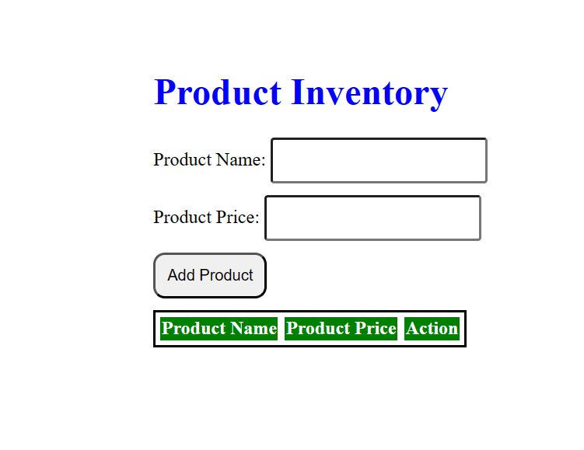

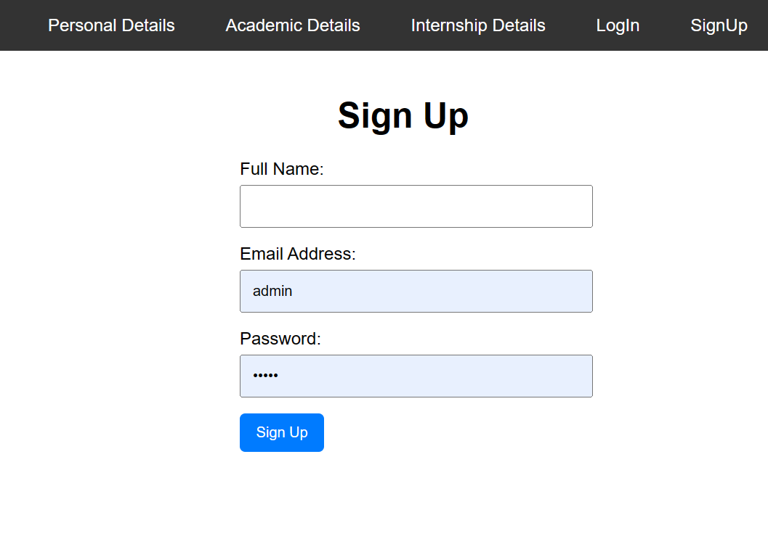

**Result**

The program is executed successfully and the program output is displayed in the web browser.